

**SCHOOL OF COMPUTING & INFORMATICS**

Course Title : **OPERATING SYSTEMS** Course Code : **CCC 2123**

**______________________________________________________________________________**

**LAB EXERCISE (WEEK 6)**

**NAME:** Modou Lamin Kinteh

**ID:** AIU2310229

**Instructions:**

Using the Command Line Interface (CLI) for Linux that we have learned and used so far, please execute the following tasks:

**Task 1: Navigation**

· Open the terminal.

· Identify and display the current location within the system. · List the contents of the current directory.

· Navigate to the home directory.

· Create a new directory and enter it.

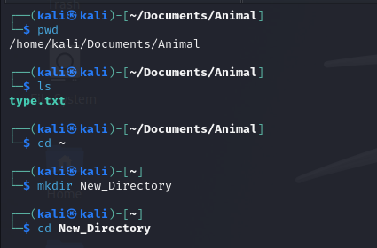

**Task 2: File Operations**

· Inside the newly created directory, create a text file. · View the contents of the text file.

· Add new content to the file.

· Duplicate the file with a different name. · Verify the creation of the duplicate file.

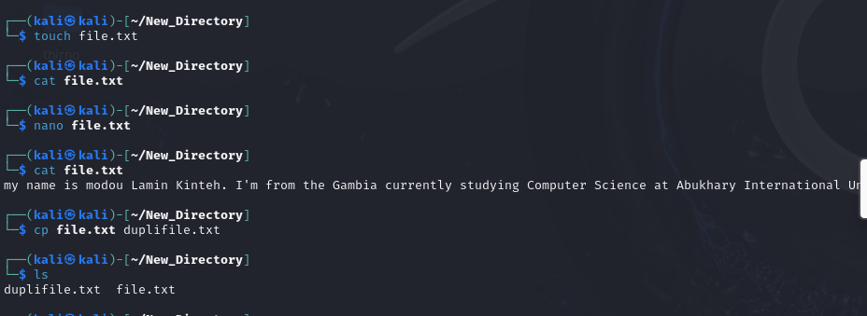

**Task 3: Directory Operations**

· Create two subdirectories within the current directory. · Move the text file to one of the subdirectories.

· Rename the second subdirectory.

· Remove one of the subdirectories and its contents.

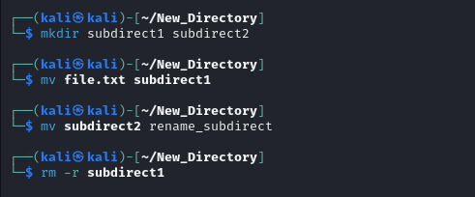

**Task 4: Permissions**

· Check and note the permissions of a specific file.

· Modify the permissions to make the file accessible only to the owner.

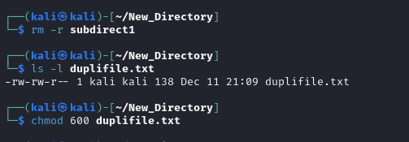

**Task 5: System Information**

· Use a command to display basic system information. · Find and report the system's memory status.

· Retrieve information about the CPU.

